AML LAB


Name-Anmol
Batch-20 AIML
Sap-590011794
Submitted to-Prof. Sahinur Laskar

Index
1 | Data Processing using Python Lib
2 | Predicting House Prices using linear Regression
3 | Predicting Stock Prices using linear Regression
4 | Customer Churn Prediction using Linear regression

1)Data processing using Python libararies

Using pandas to plot and clean data
Using matplotlib and seaborn to plt the outputs

EXE-2

Step-0 Data Processing
Python libraries such as pandas, matplotlib, and seaborn were used to handle and visualize the dataset. Pandas was used for loading, inspecting, and cleaning the data, while matplotlib and seaborn were used to generate plots that help analyze relationships between variables and understand patterns in the dataset.

Step-1 Problem Defination
The objective of this experiment is to build a machine learning model that can predict house prices using the given dataset. The dataset contains features such as area, number of bedrooms, location, and other property attributes. Since price is a continuous numeric value, this problem is a regression task. The model must learn how these features influence price and estimate it accurately.

Step-2 Data understanding
Using functions like df.head() and df.info(), the dataset structure was examined. Each row represents a house, and each column represents a feature describing that house.

The dataset contains:

Numerical features : Area, Bedrooms, Bathrooms, Age, Parking, Balcony, etc.

Categorical features : Location and Furnished

The target variable is Price, which is denoted as y, and the remaining features are used as input variables x. Since machine learning models require numeric input, categorical features must be encoded before training.

Step-3 Data Processing

Categorical variables such as Location and Furnished were converted into numerical format using one-hot encoding. This creates new columns such as:

- Location_Urban

- Location_Rural

- Furnished_Yes

This transformation was done using the get_dummies() function. Numerical features were already in usable format and therefore did not require modification. This preprocessing step ensures the dataset is suitable for machine learning algorithms. This aligns with the preprocessing stage of the pipeline where raw data is transformed into model-ready numerical form

Step-4 Data Selection and Model Training

As discussed earlier, Price was selected as the target variable (y), and all other columns were selected as input features (x). For demonstration purposes, the model was trained on the full dataset instead of splitting into training and testing sets.

The model chosen was Linear Regression, since the dependent variable is continuous. Regression models are specifically designed to predict numeric outputs, unlike classification models which predict categories.

Step 5-Prediction
After training, the model was used to generate predictions using the .predict() function. By providing input feature values (X), the model calculates estimated house prices based on the learned relationship between features and target variable.

Step-6 Evaluation
The model performance was evaluated using:

Mean Squared Error (MSE) -- measures average squared difference between predicted and actual prices
R^2 Score - measures how well the model explains variation in price .
The obtained values showed MSE close to zero and R² close to 1, indicating that the model fit the training data extremely well. According to regression evaluation theory, lower MSE
Additionally, the results were visualized using a scatter plot to compare predicted prices with actual prices, allowing visual inspection of model accuracy.
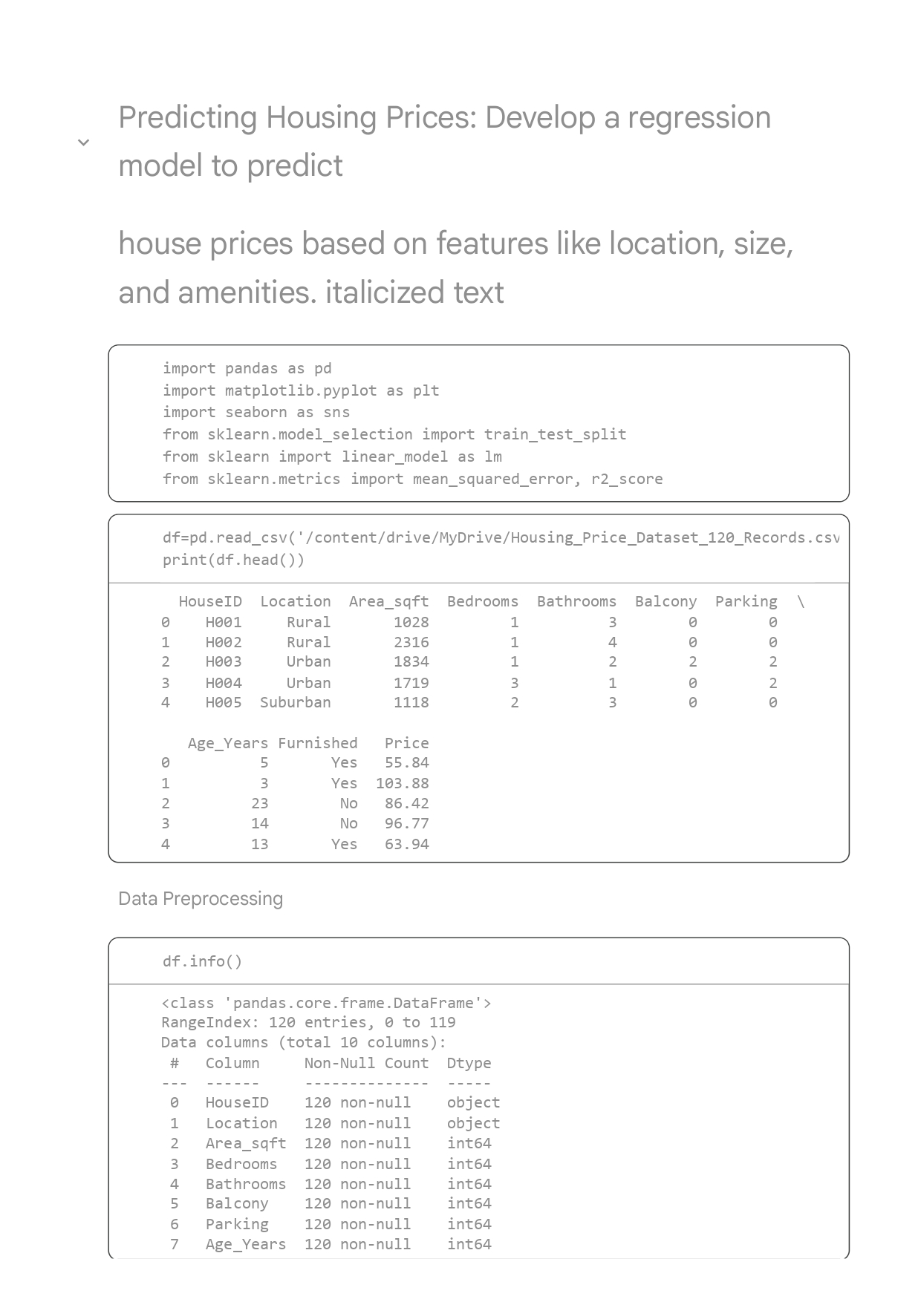
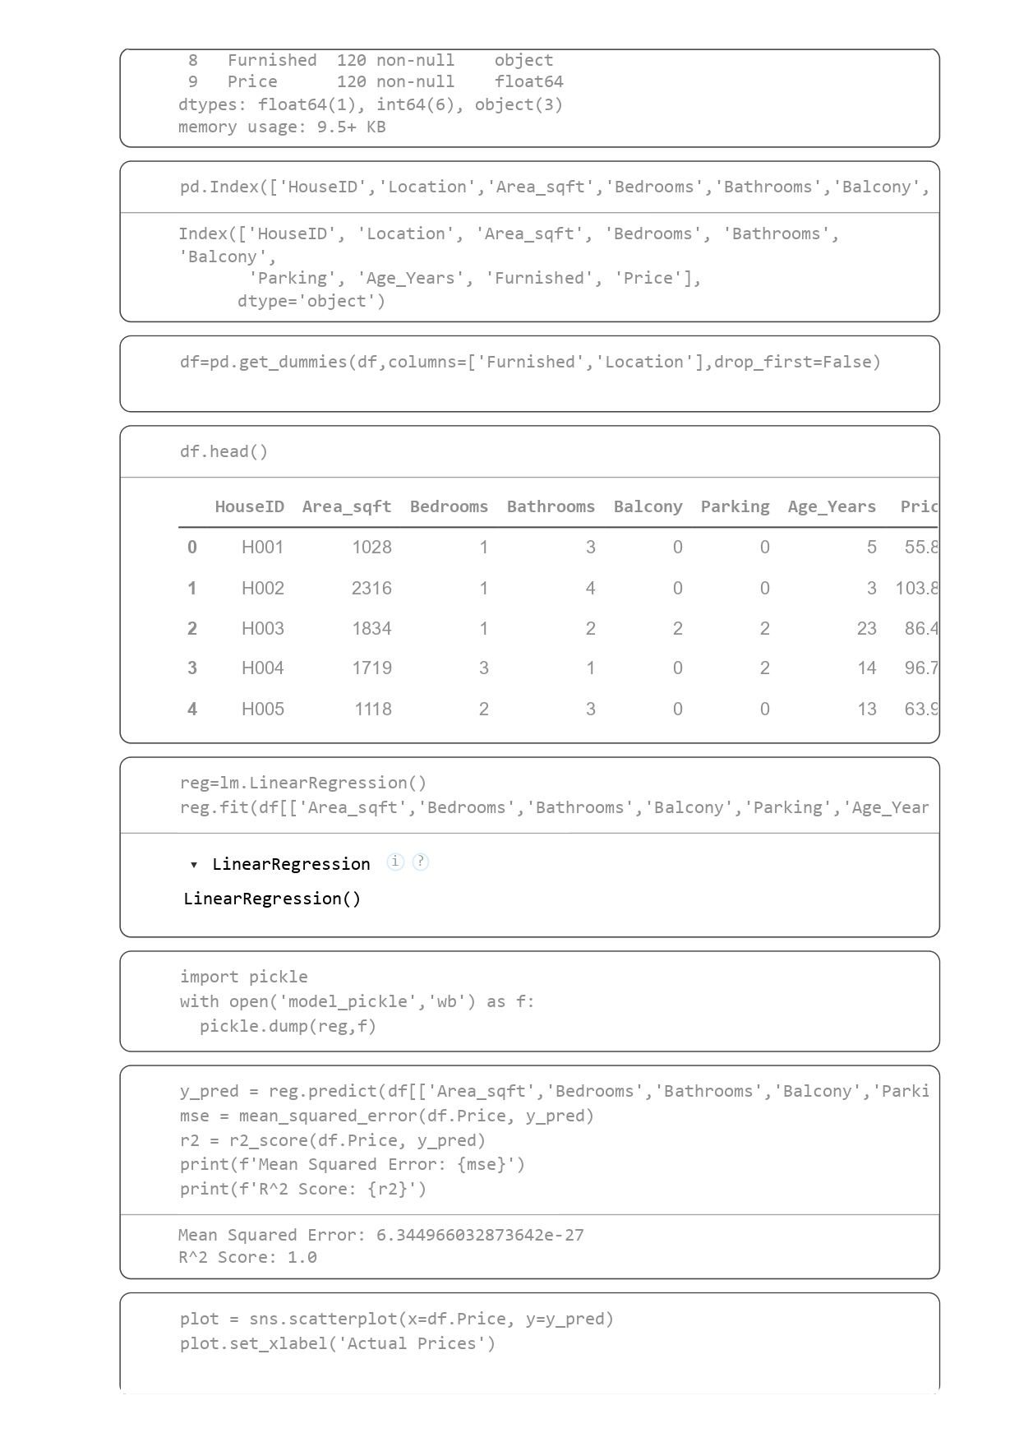
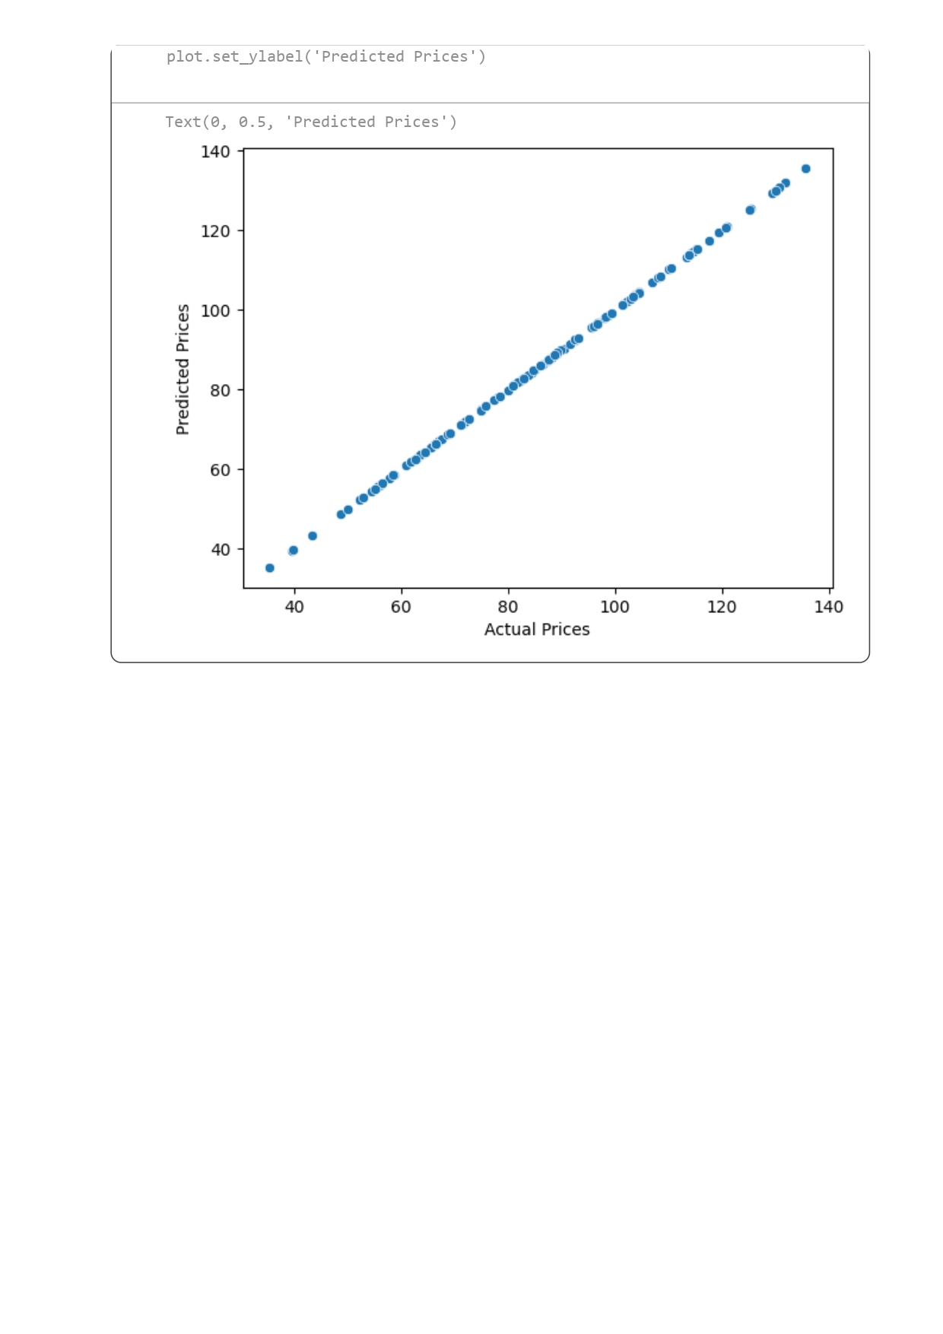

EXE-3

Step-0 Libraries Used
Several Python libraries were used to perform data handling, model training, evaluation, and visualization for stock price prediction.
NumPy: was used for numerical operations and array manipulation required during model input preparation.
Pandas: was used for loading the dataset, filtering stock data, converting date formats, and creating new features such as the numerical time variable (Days).
Matplotlib and Seaborn: were used for visualization to plot stock price trends and analyze the distribution of values.
Scikit-learn: was used to implement machine learning functionality. The train_test_split module was used to divide data into training and testing sets, the LinearRegression model was used for prediction, and evaluation metrics such as Mean Squared Error and R² score were used to assess model performance.
Pickle: was used to save the trained model so it can be reused later without retraining.

Step-1 Problem Definition

The objective of this experiment is to develop a time series prediction model to forecast stock prices. The dataset contains historical stock data including Date, Open, High, Low, Close prices, and Volume for different companies. Since the output variable (stock price) is numeric and changes over time, this is a regression-based time series prediction problem.

Step-2 Data Understanding

The dataset was loaded using pandas and inspected to understand its structure. Each row represents a stock record for a specific date, and each column represents a feature describing that day’s market performance.

The dataset contains the following attributes:

- Date → trading day

- Stock → company ticker symbol

- Open, High, Low, Close → price values

- Volume → number of shares traded

As shown in the dataset, the data contains multiple stocks such as AAPL and TSLA ,For modeling purposes, only one stock (AAPL) was selected so that a single time series could be analyzed.

Step-3 Data Preprocessing

The Date column was converted into datetime format to enable time-based calculations. A new feature called Days was created by subtracting the minimum date from each date value. This converts time into numerical form representing the number of days since the start of the dataset.
This step is necessary because machine learning models cannot directly process date values; they require numerical inputs.

Step-4 Feature Selection, Model Selection and Training

In this step, the input (X) was taken as the Days column, which represents time in numeric form, and the output (y) was selected as the closing stock price.

The dataset was divided into training and testing sets using an 80:20 ratio. Shuffling was disabled so that the chronological order of dates remains unchanged. This is important for time-series data because predictions should always be made using past values to estimate future ones.

A Linear Regression model was chosen for this task because the target variable is continuous. The model was trained using the training data, where it learned the relationship between time and stock price by fitting a line that minimizes prediction error. After training, the model parameters were stored so that it could later be reused without retraining.

Step-6 Prediction

After training, the model was used to predict stock prices for the test dataset. The predictions generated represent estimated closing prices based solely on time progression.

As shown in the output, the predicted values form a continuous decreasing trend, indicating the model learned a linear relationship

Step-7 Evaluation

Model performance was evaluated using two regression metrics:

- Mean Squared Error (MSE):Measures average squared difference between predicted and actual values. Lower values indicate better performance.

- R² Score:Measures how well the model explains variance in the data. Values closer to 1 indicate better fit.

From the results :
MSE is approx.= 3072
R² is approx.= −11.21
The negative R² indicates the model performs poorly and does not fit the data well. This occurs because stock prices follow nonlinear patterns, while linear regression can only model straight-line relationships.

Predicting Stock Prices: Develop a time series prediction model to forecast stock prices.
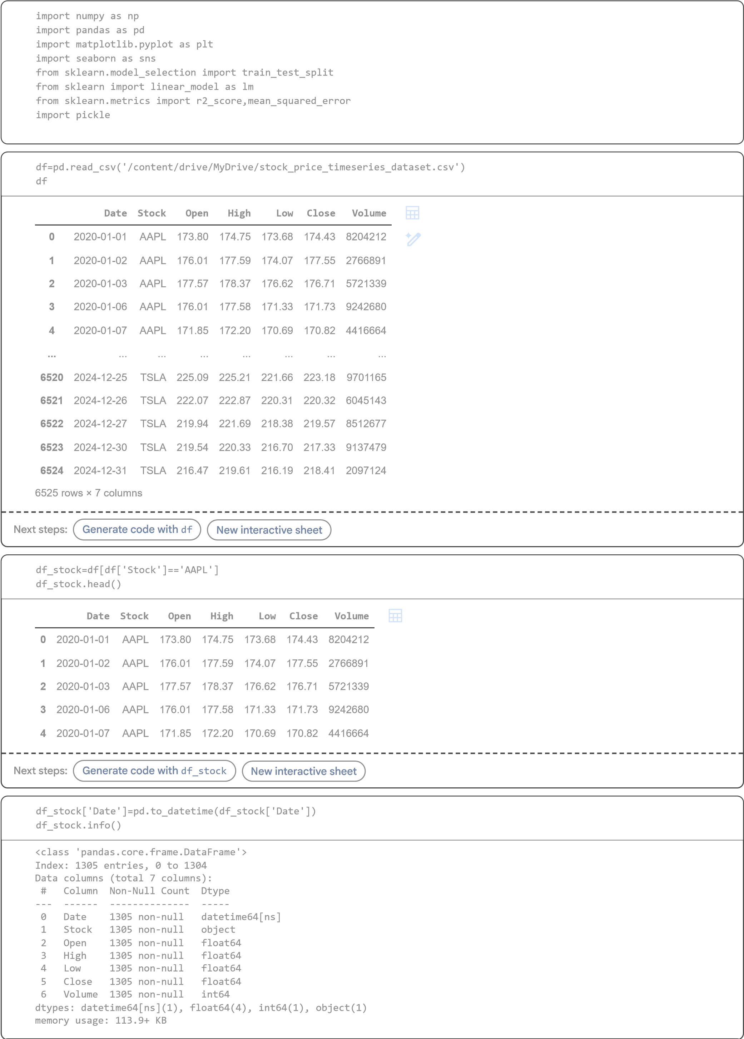
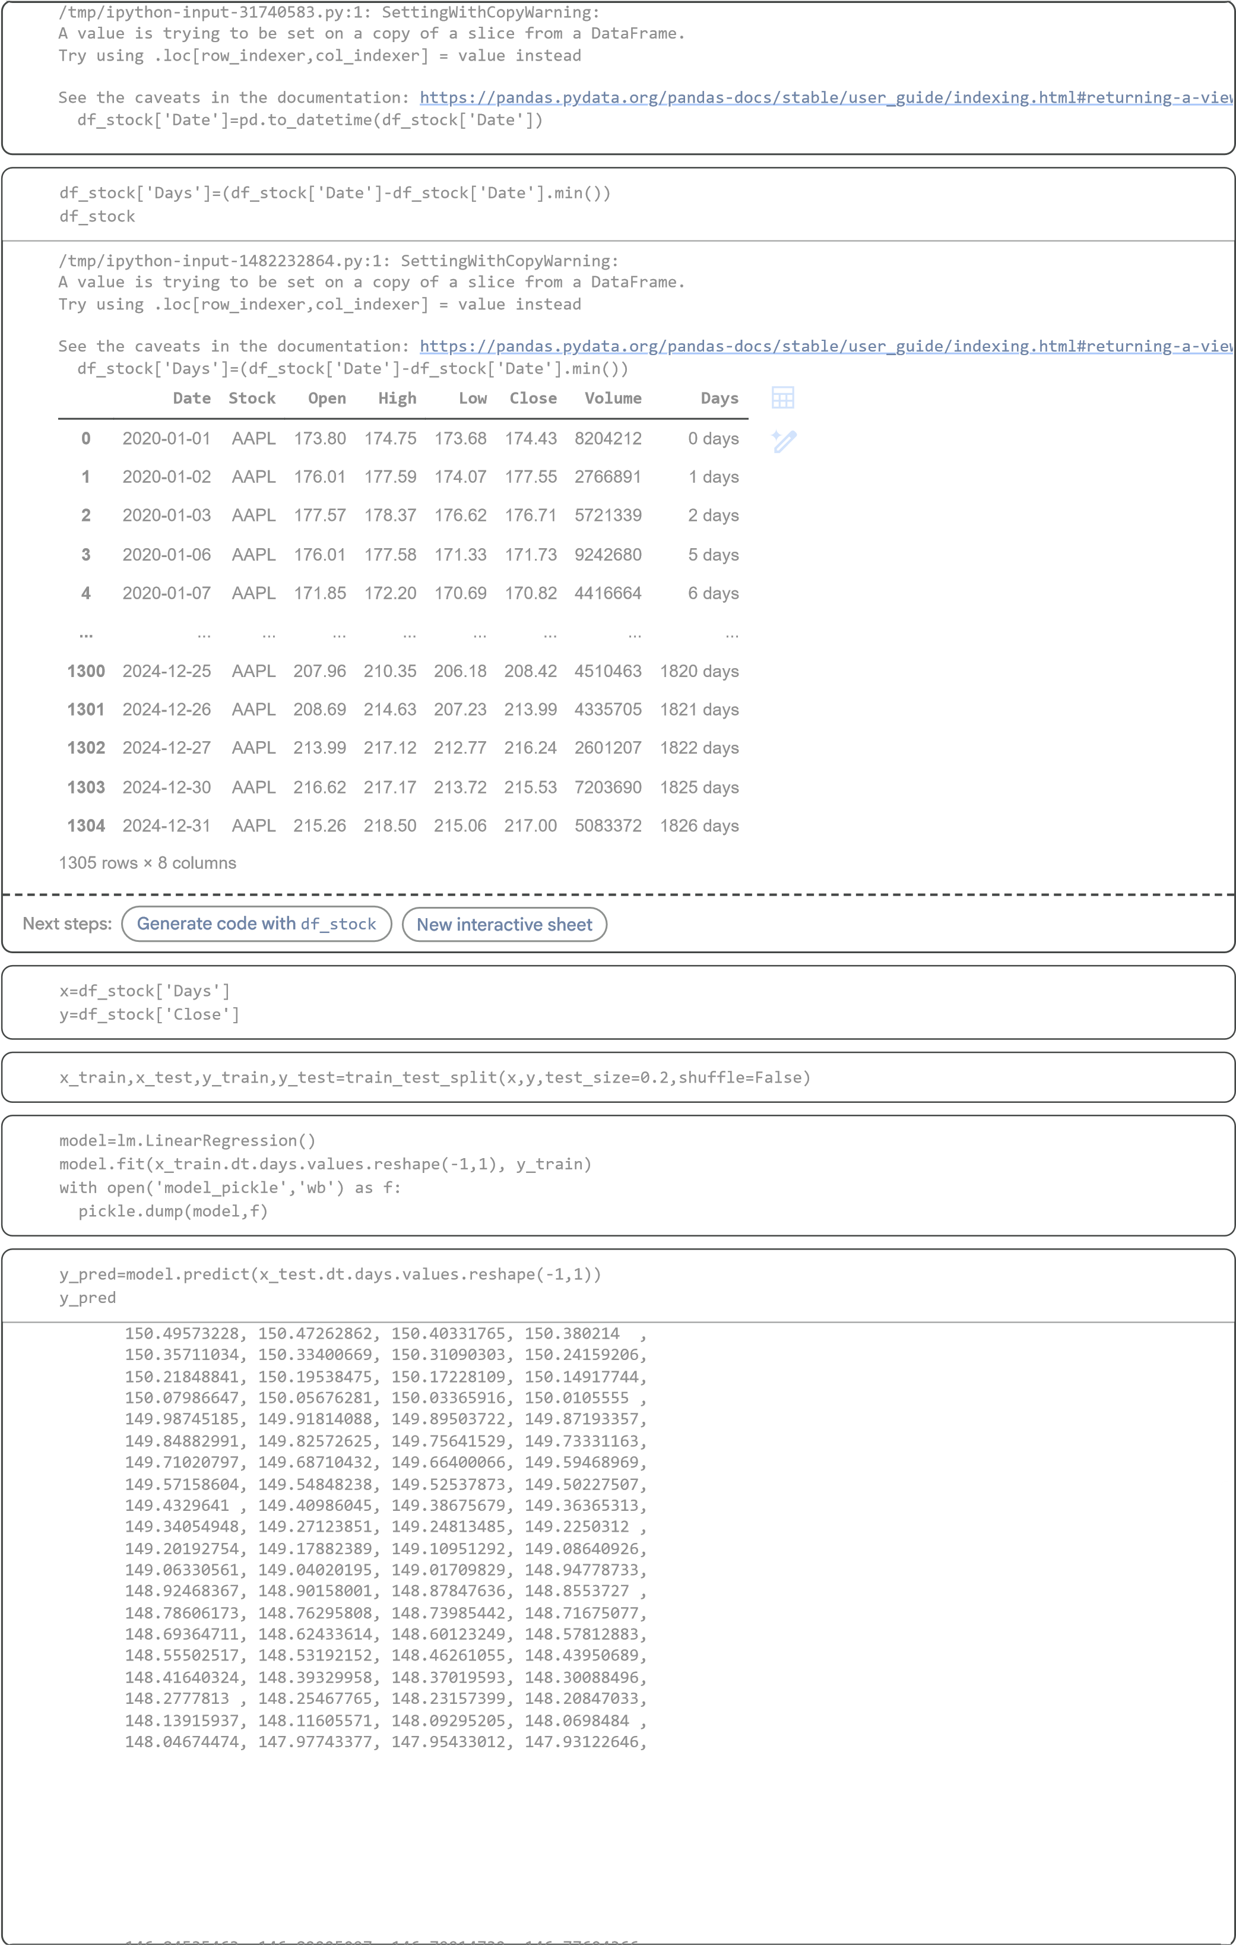
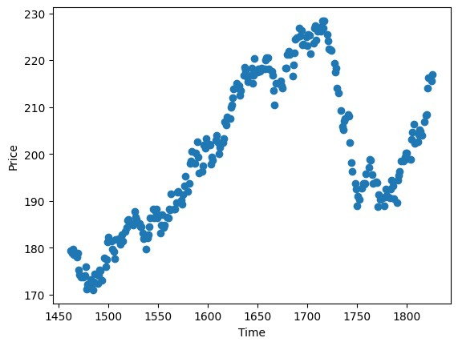

,
146.84535463, 146.82225097, 146.79914732, 146.77604366

146.75294001, 146.68362904, 146.66052538, 146.63742173
,

146.61431807, 146.59121441, 146.52190345, 146.49879979
,

146.47569613, 146.45259248, 146.42948882, 146.36017785
,

,
146.3370742 , 146.31397054, 146.29086689, 146.26776323

,
146.19845226, 146.17534861, 146.15224495, 146.12914129

,
146.10603764, 146.03672667, 146.01362301, 145.99051936

,
145.9674157 , 145.94431205, 145.87500108, 145.85189742

145.82879377, 145.80569011, 145.78258645, 145.71327549
,

145.69017183, 145.66706817, 145.64396452, 145.62086086
,

145.55154989, 145.52844624, 145.50534258, 145.48223893
,

,
145.45913527, 145.3898243 , 145.36672065, 145.34361699

145.32051333, 145.29740968, 145.22809871, 145.20499505
,

145.1818914 , 145.15878774, 145.13568409, 145.06637312
,

,
145.04326946, 145.02016581, 144.99706215, 144.97395849

,
144.90464753, 144.88154387, 144.85844021, 144.83533656

144.8122329 , 144.74292193, 144.71981828, 144.69671462
,

144.67361097, 144.65050731, 144.58119634, 144.55809269
,

144.53498903, 144.51188537, 144.48878172, 144.41947075
,

144.39636709, 144.37326344, 144.35015978, 144.32705613
,

,
144.25774516, 144.2346415 , 144.21153785, 144.18843419

144.16533053, 144.09601957, 144.07291591, 144.04981225
,

144.0267086 , 144.00360494, 143.93429397, 143.91119032
,

143.88808666, 143.86498301, 143.84187935, 143.77256838
,

143.74946473, 143.72636107, 143.70325741, 143.68015376
,

143.61084279, 143.58773913, 143.56463548, 143.54153182
,

143.51842817, 143.4491172 , 143.42601354, 143.40290989
,

143.37980623, 143.35670257, 143.28739161, 143.26428795
,

,
143.24118429, 143.21808064, 143.19497698, 143.12566601

143.10256236])
mse=mean_squared_error
(
y_test
,
y_pred
)
mse
3072.378496877529
r2=r2_score
(
y_test
,
y_pred
)
r2
-11.213999810715315
Text(0, 0.5, 'Price')
plt.scatter
(
x_test.dt.days
,
y_test
)
plt.xlabel
(
'Time'
)
plt.ylabel
(
'Price'
)

EX-4
Step-0 Libraries Used

Pandas: is used to load and analyze data.
NumPy: is used for numerical operations.
Matplotlib and Seaborn: are used for plotting graphs.
Scikit-learn: is used for train test split, model training, prediction, and evaluation.
Pickle: is used to save the trained model for later use.

Step-1 Problem Definition

The goal is to predict whether a customer will churn or not using customer information such as age, subscription type, payment method, and charges. Since the output is either 0 or 1, this is a binary classification problem.

Step-2 Data Understanding

The dataset was loaded and checked using head() and info() to understand structure. Each row represents a customer and each column represents a feature.

The dataset contains numerical features such as age, tenure, charges, and support tickets, and categorical features such as gender, subscription type, payment method, and contract type. The target column is Churn.

Step-3 Data Processing

The CustomerID column was removed because it is only an identifier and does not help prediction. Categorical columns were converted into numerical form using one-hot encoding so that the model can understand them.

Step-4 Feature Selection and Model Training

All columns except Churn were selected as input (x), and Churn was selected as output (y). The dataset was split into training and testing sets in 80:20 ratio. A Logistic Regression model was chosen because it is suitable for binary classification. The model was trained on training data to learn patterns between customer features and churn.

Step-5 Prediction

After training, predictions were generated using the test data. The model outputs either 0 (not churn) or 1 (churn) based on learned patterns.

Step-6 Evaluation

The model performance was evaluated using accuracy, precision, recall, and F1 score. The accuracy was about 0.75, which shows the model performs reasonably well. However, precision and recall were lower, meaning the model has difficulty correctly identifying churn customers.

A confusion matrix was plotted to visualize prediction performance and to see correct and incorrect classifications.
Step-7 Feature Impact

A graph of model coefficients was plotted to see which features influence churn prediction the most. Features related to subscription type, payment method, and contract duration showed strong impact.

Customer Churn Prediction: Develop a model to predict customer churn in a
subscription-based business
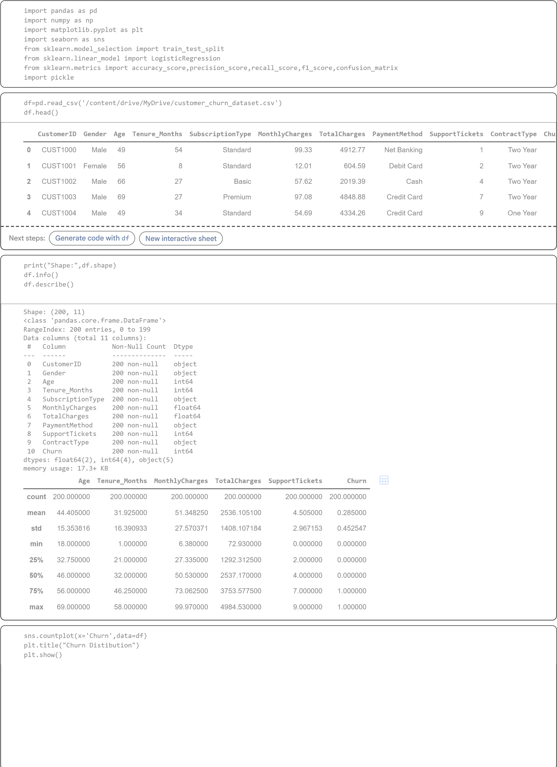
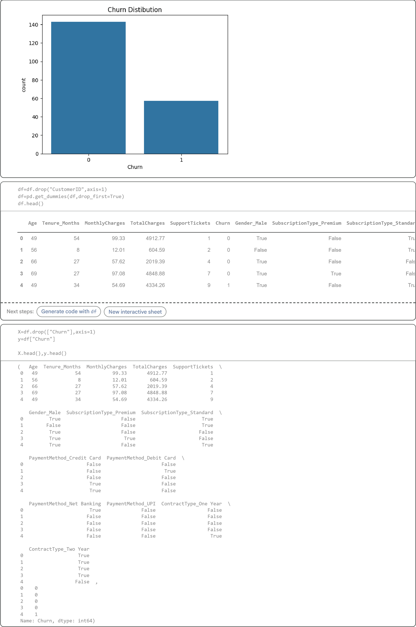
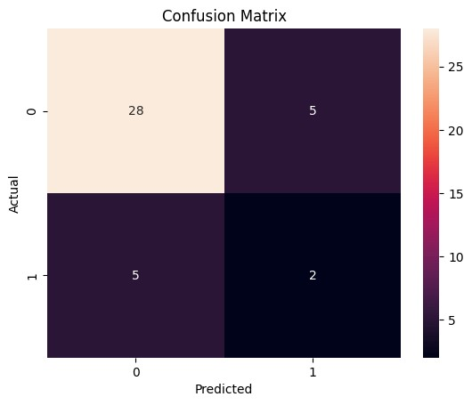
X_train
,
X_test
,
y_train
,
y_test=train_test_split
(
X
,
y
,
test_size=
0.2
,
random_state=
42
)
print
(
"Train size:"
,
X_train.shape
)
print
(
"Test size:"
,
X_test.shape
)
Train size: (160, 14)
Test size: (40, 14)
model=LogisticRegression
(
max_iter=
1000
)
model.fit
(
X_train
,
y_train
)
with

open
(
"model"
,
"wb"
)

as
f
:
pickle.dump
(
model
,
f
)
/usr/local/lib/python3.12/dist-packages/sklearn/linear_model/_logistic.py:465: ConvergenceWarning: lbfgs failed to converge (status=1):
STOP: TOTAL NO. OF ITERATIONS REACHED LIMIT.
Increase the number of iterations (max_iter) or scale the data as shown in:

htt
ps://scikit-learn.or
g
/stable/modules/pre
processin
g
.htm
l
Please also refer to the documentation for alternative solver options:

n
ressio
htt
ps://scikit-learn.or
g
/stable/modules/linear_model.html#lo
g
istic-re
g
n_iter_i = _check_optimize_result(
y_pred=model.predict
(
X_test
)
y_pred
array([0, 0, 0, 0, 1, 0, 0, 0, 1, 0, 0, 0, 0, 0, 1, 0, 0, 0, 0, 0, 0, 0,

1
, 0, 0, 0, 1, 0, 0, 1, 0, 0, 0, 0, 0, 1, 0, 0, 0,
0])
print
(
"Accuracy:"
,
accuracy_score
(
y_test
,
y_pred
))
print
(
"Precision:"
,
precision_score
(
y_test
,
y_pred
))
print
(
"Recall:"
,
recall_score
(
y_test
,
y_pred
))
print
(
"F1 Score:"
,
f1_score
(
y_test
,
y_pred
))
Accuracy: 0.75
Precision: 0.2857142857142857
Recall: 0.2857142857142857
F1 Score: 0.2857142857142857
cm=confusion_matrix
(
y_test
,
y_pred
)
sns.heatmap
(
cm
,
annot=
True
,
fmt=
'd'
)
plt.xlabel
(
"Predicted"
)
plt.ylabel
(
"Actual"
)
plt.title
(
"Confusion Matrix"
)
plt.show
()
coef=pd.Series
(
model.coef_
[
0
]
,
index=X_train.columns
)
coef.sort_values
(
)
.plot
(
kind=
"barh"
,
figsize=
(
8
,
6
)
)
plt.title
(
"Feature Impact on Churn"
)
plt.show
(
)

